EDL Event System
Design Document

Version: | V 1.0
Owner: | Lixin Cheng

Change log
Version | Date | Description | Updated by | Approved by
1.0 | 6/6/2011 |  | Lixin Cheng
1.1 | 6/9/2011 | Drop the EventProcessing table. Add a new field JSONResponse  The original field JSONContent is renamed as JSONRequest to pair with JSONResponse | Lixin Cheng

1. Introduction
This is the design document for EDL event processing framework. It is part of the EDL system and mainly focuses on setting up the generic event request and handling framework.

- Definitions
  - EDL Events are the process requests for EDL system. They are defined by classes inherit from base event class and persist/transfer in JSON format.
  - Event Handlers are the “workers” process the event requests. They are classes implement the EDL Handler interface. Each type of event handler will be map to a specific event type. By the convention, the event handler’s name will be in the format as “[EventType]Handler”.
  - Processors are the applications which receive the event requests and instantiate the corresponding event handler to kick off the processing
  - Event Table will be the storage for persisted events. It’s a MySQL table which holds basic event attributes and event object serialized to JSON format. The detailed event processing status/exception/information will be stored in a response event object, and persisted as JSON in JSONResponse field.

- Functionalities
  - An EDL event can be created by inserting an event record in Event table, the status is default as New
  - Processor will be checking on event table for next available event to process. When an unprocessed event is available, the processor will take the event record, de-serialize the JSON field content into the event object, instantiate the corresponding event handler instance, and kick off the processing for this event
  - When an event is finished processing, the result status will be updated back into event table

2. Overview
Logical Diagrams
- Basic Event Flow
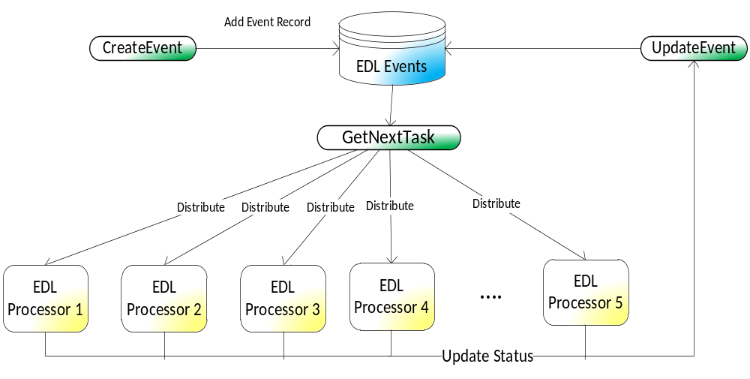
- Add EDL Event
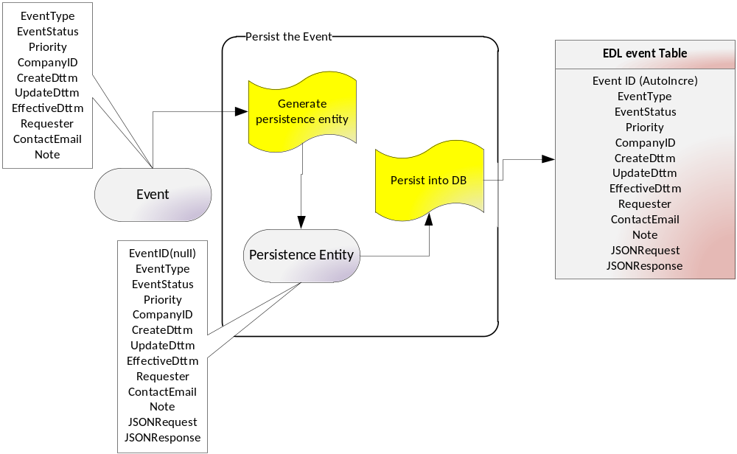
- GetEvent(by ID)
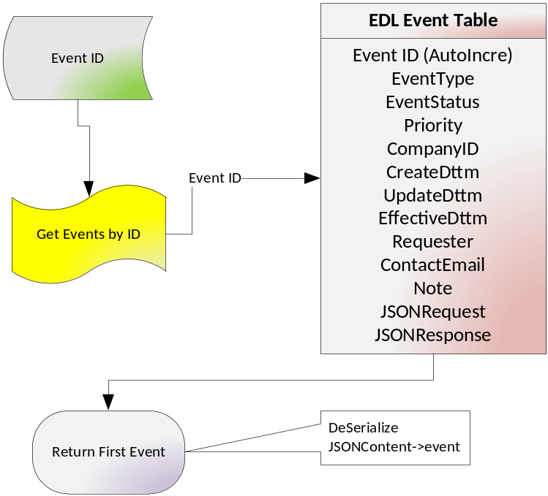
- Get Next Task
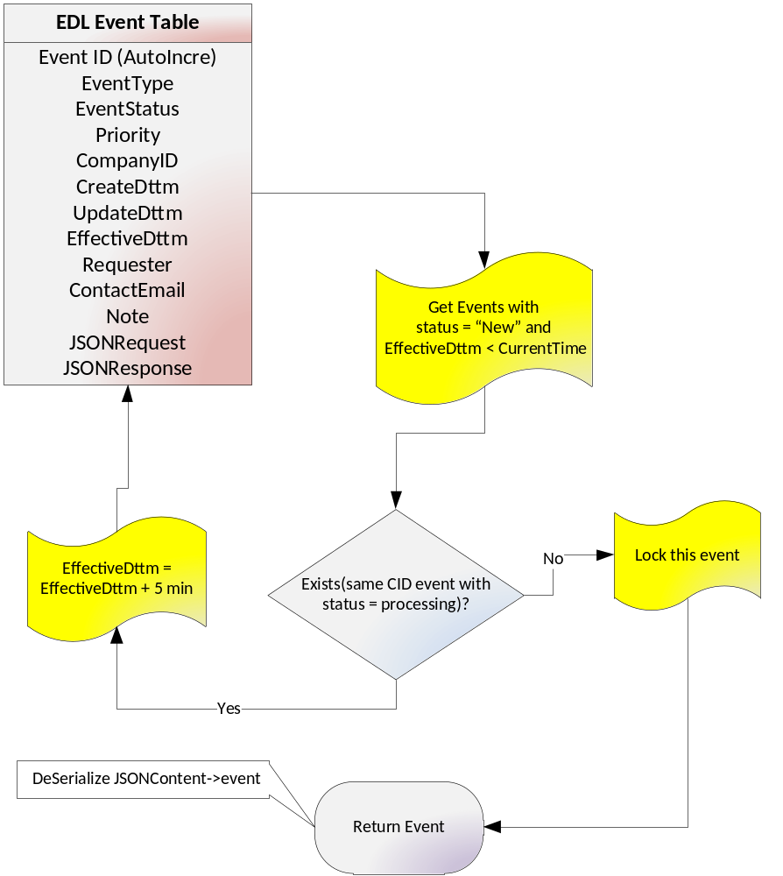
- Update Event
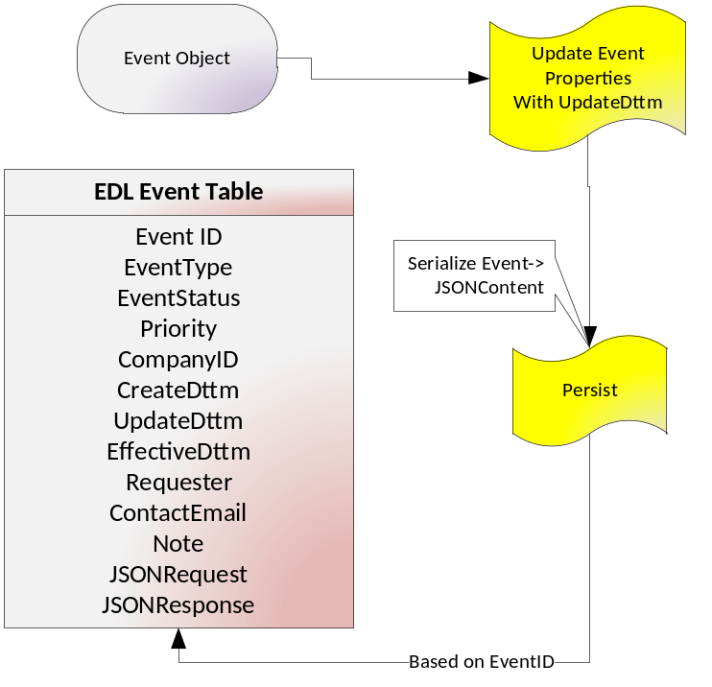
Key Functionality
- Create new event
Input:
EventType
EventStatus – default to “NEW”
Priority - default to 0
CompanyID
CreateDttm – Normally is the current system date time
UpdateDttm – default to same as CreateDttm
EffectiveDttm – default to current system date time
Requester - the account that submitted the event
ContactEmail – the email account which is used for receiving notice

Expected Result:
The new record will be added into EDL event table in MySQL.
All the fields are filled in with corresponding values.
EventID field be automatically filled by an incremental number
JSONRequest is JSON string serialized from the event object.
JSONResponse is JSON string serialized from the response object

- Get event
Input:
EventID

Expected Result:
Based on the unique event ID, return the EDL event object.
The wrapper will retrieve the corresponding event record from table and de-serialize the JSONRequest string and append the event ID. The result object is returned with event ID included.

- Update Event
Input:
Event object with updated properties
Expected result:
The DB record for this event will be update accordingly. The JSONResponse and JSONResponse will be updated as well

- Get Next Task
Input:
No
Expected Result:
Get all the events, with status=”NEW” from event table, order by EffectiveDttm. From the top of the list, if the related Company is under processing now(in event table with another event for same company with status “processing”), then the add 5 minutes to EffectiveDttm and save the event back to event table. Return the first event which has the company ID not under processing in EDL now

Assumptions
- Each event will be related t one company. If the event is ShareClass based, we can still find the CompanyId for this share class. So it will make sure for the same company, there are no more than one event under processing in EDL.

3. Details
Modules/Decision Points
- BaseEvent and subclasses
We will define the BaseEvent as the root of event classes. The base event includes common properties for all the event types like EventType, CreateDttm, UpdateDttm, Priority...etc.

The persisted event will be stored in EDLEvent table in MySQL server.
All the properties in BaseEvent will be stored into corresponding fields in EDLEvent table. Besides, the EventID will be an auto-incremental field holds the unique key. JSONRequest field will store the event object serialized into JSON String.

- BaseResponse and subclasses
We will define the BaseResponse as the root class for all response types. The BaseResponse class will only hold the common properties for all the response types. Derived response classes will define the additional properties for specific needs.
In the event table, the response object will be persisted as JSON string in JSONResponse field.

- IEventHandler and implementation
IEventHandler will be the java interface to define the event handler method set. The process() method in the interface takes the BaseEvent object as input. Any class implemented the IEventHandler will be able to process the corresponding request event. The getHandlerType method will return the information about the concrete handler type.
Naming convention: The IEventHandler implementation class will be named following the event type it handles. For example, FinancialDataEvent will be handled by FinancialDataEventHandler.

- EDLEvent persist module
This module will wrap up the common operations for event persistence.
It will create a persistence entity, clones all the properties from an event(derived by BaseEvent) and including additional three fields: EventID, JSONRequest and JSONReponse. EventID will be null(for DB generating) and JSONRequest will be JSON string serialized from the input event object. JSONResponse field will keep the JSON string serialized from the event response object(defined by BaseResponse and its subclasses)

- EDLProcessor
EDL Processor is the main program which request for the next task, instantiate the corresponding event handler instance and kick off the process() method.

Interface (internal and external)
Database

EDLEvent table

Column name | Type
EventID |  | Key | Auto-Incremental
EventType
EventStatus
Priority
CompanyID
Requestor
ContactEmail
Note
JSONRequest
JSONResponse
EffectiveDttm
CreateDttm
UpdateDttm

4. System Characteristics
Physical Deployment Diagrams
- Item1
- Item2
Failover/BCP stratey
- Item1
- Item2
Security Considerations
- Item1
- Item2
Launch Plan
- Item1
- Item2
Monitoring
- Item1
- Item2
Data Retention
- Item1
- Item2
5. Testing Strategy
Unit Testing
- Item1
- Item2
System Testing
- Item1
- Item2
Performance Testing
- Item1
- Item2
Failover/Stability Testing
- Item1
- Item2

